PH126 Logic I Lecture 15
Lecturer: s.butterfill@warwick.ac.uk
Quantifiers and identity
Ahura Mazda created everything:
∀x Created(a,x)
Ahura Mazda created everything apart from himself: ∀x ( ¬(x=a) → Created(a,x) )

Quantifier proof exercise
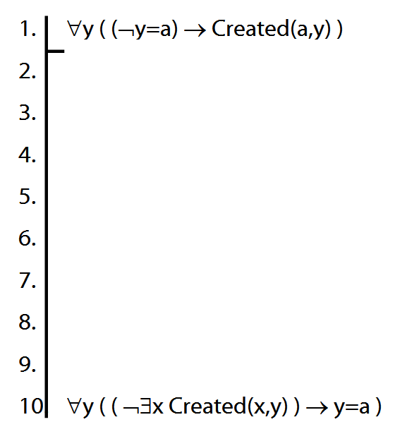

Number
There are at least two squares:
∃x ∃y ( Square(x) ∧ Square(y) ∧ ¬x=y)
At least two squares are broken:
∃x ∃y ( Square(x) ∧ Broken(x) ∧ Square(y) ∧ Broken(y) ∧ ¬x=y)
There are at least three squares:
∃x ∃y ∃z ( Square(x) ∧ Square(y) ∧ Square(z) ∧ ¬x=y ∧ ¬y=z ∧ ¬x=z)
There are at most two squares:
¬There are at least three squares
¬∃x ∃y ∃z ( Square(x) ∧ Square(y) ∧ Square(z) ∧ ¬x=y ∧ ¬y=z ∧ ¬x=z)
There are exactly two squares:
There are at most two squares ∧ There are at least two squares
Number: Alternatives
There is at most one square:
∀x∀y( (Square(x) ∧ Square(y)) → x=y )
There are at most two squares:
∀x∀y∀z( (Square(x)∧Square(y)∧Square(z))
→
(x=y∨y=z∨x=z)
)
There is exactly one square:
∃x ( Square(x) ∧ ∀y( Square(y) → x=y ))
There are exactly two squares:
∃x∃y (Square(x) ∧ Square(y) ∧ ¬x=y ∧
∀z( Square(z) → (z=x ∨ z=y) ))

The
‘The’ can be a quantifier, e.g. ‘the square is broken’. How to formalise it?
The square is broken
There is exactly one square and it is broken
There is at most one square and there is at least one square and it is broken
There is at most one square and there is at least one square and all squares are broken
¬ ∃x ∃y ( Square(x) ∧ Square(y) ∧ ¬x=y )
∧ ∃x Square(x)
∧ ∀x ( Square(x) → Broken(x)
Which shorter sentences are equivalent to this?
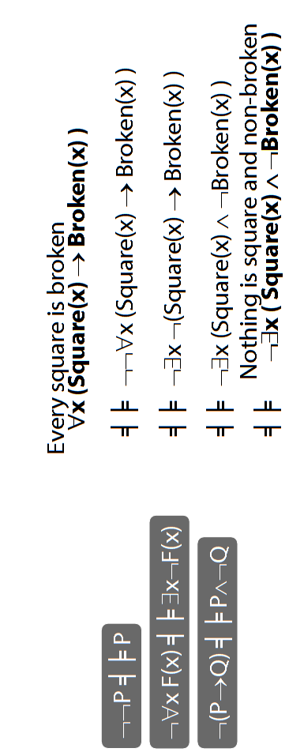

Exercises 08
There isn’t a seminar for these; you should attempt them over the vacation.
Not for fast groups
11.11, 11.13, *11.10
13.6–7, *13.8–9
13.19, 13.23–27 (*13.28–31)
(*13. 33, 35, 37, 39)
13.43–45, 13.49–50, *13.51–52
14.1, 14.2, 14.3 (*14.4–5) [trans]
*14.10–12, *14.13 [proofs]
*14.26, 14.28 [trans]

Despite what book says, DON’T even THINK about using TAUT CON.
Short of time? Skip the exercises marked *

